**EE Senior Design**

**Project Statement of Work**

**Ingram project**

**Texas State University**

**Ingram School of Engineering**

**AHMED AL QAYSI**

**ANDRES OLIVA, NICHOLAS HOLLEMAN**

**Charlie Will Tuttle, Ingram Ready Mix**

**Transportation Way**

**San Marcos, tx 78666**

# 11/24/2019





|  |  |  |  |
| --- | --- | --- | --- |
| **Revision History** | | | |
| **Version** | **Date** | **Description** | **Author** |
| 1.0 | 2/13/19 | Initial draft |  |
| 1.1 | 2/15/19 | Review draft I |  |
| 1.2 | 2/18/19 | Final draft |  |
| 2.0 | 11/24/19 | D2 update, Section 3,4 | Nicholas, Andres |

**Table of Contents**

11/24/2019 1

1. Executive Summary 3

2. Business Need 3

3. Product Scope Description 4

4. Project Scope Description 7

5. Sponsor Support Elements 8

6. Approvals 9

# Executive Summary

Andres Oliva:

The Ingram Readymix design project will be a self-diagnostic remote monitoring system. This project will be beneficial for the facility in the aspect that it will require fewer employees to check up on the retention pond components located outside the facility. The project will be possible with some voltage sensors that will be installed to allow users to check the status of the retention pond remotely from the office. Not only will this project help the facility gain efficiency when checking the retention pond, but it will also help prevent possible future fines by alerting workers when there is an outflow event. Sponsoring this project will be beneficial to reduce the amount of time that is spent going outside by making the current project a remote, fully automated system.

As a team, we will be working on making a fully automated system with a suite of diagnostic tests and failure forecasting. To assist the user in managing the system over the long-haul and to pinpoint areas of the system failures or errors. These features will be monitored and displayed inside the office.

# Business Need

Nicholas Holleman:

At the Ingram Readymix, the existing process for monitoring runoff from concrete manufacturing is ineffective. The process currently requires an employee to physically go outside and check on the pond during and after heavy rainfall. Due to heavy rainfalls, this causes what is known as a stormwater outflow event (SWO). A stormwater outflow is recognized as a problem when the water level flows above the first level of the retention gate. Ingram Readymix must collect a sample from the retention pond within 30 minutes to comply with the Texas Commission on Environmental Quality (TCEQ) Permit requirements (TXR050000). Besides, employees must also monitor the rainfall amount weekly during a storm outflow event. As a result, a fully automated failsafe operation of the outflow monitoring system is a paramount concern.

This portion of the Ingram project will provide an office display and an application that will access the remote pond unit. The program will be displayed on the office display and will allow the user to manually check voltage/current sensors, calibrate sensors, monitor the antenna status, check who is connected to the network, and if the client/server application is running. The main voltage and current sensor concerns originate from the battery. The voltage and the current drawn from the battery will be used to calculate the battery’s capacity and how long the battery will last under its current amp usage. This information will be tracked, generate a forecasted life span and reported them. The solar panel, battery management unit (BMU) current and voltages combined data can confirm the battery is charging and will adjust the expected time to alert that the battery needs to be replaced. The current sensor on the BMU will also provide an overload or over-charging status. The sensors that will be implemented into this project will be capable of being calibrated. The calibration will allow Ingram to verify that a current or new sensor is functioning as expected.

With an office display that can provide notifications and alerts of the battery life, antenna and network functionality, and sensor calibrations; Ingram Readymix will be able to rely on the data present. This project will help determine a course of action to correct the malfunction. This will be helpful to reduce the work labor and maintenance required to keep the system up to date and stable.

# Product Scope Description

Andres Oliva:

The design of the Ingram Readymix project will be highly software oriented. There will be two different units. The main component that will be used per unit will consist of a Raspberry Pi 3 Model B. Attached to this credit-card sized computer will be some sensors to help gather useful data that will then be transferred to the unit inside the office. The first unit will be located inside an office space. The office unit will include a touch screen display for user interaction as well as displaying error messages. The unit inside the office will be receiving information from the outside unit. This information will consist of battery health as well as the voltage from the solar panel and power management. The detectable errors should be network recognized and should ensure that the remote components are responding and working correctly. Each unit will be able to perform a self-diagnostic test from one side to another in order to determine if there are any problems and try to resolve it.

Additionally, a second unit will be located outside and attached to the outflow gate. The remote site will perform several diagnostics and report these results to the unit inside the office. The system outside is made up of several components like a battery, an antenna and a solar panel. A micro-controller, voltage and current sensors will be implemented to create a power management system that will regulate, and monitor energy dissipated throughout. The diagnostics that can be performed on these components can check that the battery is charged and providing power, it can also check to make sure that the antenna is online and transferring information. It will also periodically check to verify that the solar panel is producing enough energy to power the system and ensure that the battery management unit is providing power.

**Product Features**

* Product will feature a display to show system status with an alert system.
* A self-system diagnostic will also be implemented to ensure that all components in the system and functioning properly.
* Power management system to monitor and regulate energy.
* Data ledger to store sensor readings.
* Secure communication.

**Stretch goals**

* Implementing more sensors such as a liquid level sensor, a water flow sensor for the retention pond to obtain different types of data.
* Web application for remote mobile use.

|  |  |
| --- | --- |
| **Features** | **Performance Targets** |
| **Graphical User Interface** | |
| Display | 7” Touchscreen with graphical user interface that can guide user through Alerts and battery health, and current/past water levels. |
| Battery health | Track, monitor and forecast battery life based on solar panel, battery and battery control sensor. |
| **Diagnostic** | |
| Antenna detection | Antenna detection will verify both antennas, power when need. |
| Network connection | Check to see if the other pi is currently available on the network. |
| Solar panel voltage sensor | This sensor checks the solar panel voltage and will be used to determine if the panel can send current to the battery controller. |
| Solar panel current sensor | Solar current sensor will state if the battery control unit is accepting current from the solar panel to the charge battery. |
| Battery control Sensor | This sensor will determine if the system is causing an overload and confirm if another sensor is reasonable. |
| Battery voltage sensor | The battery voltage sensor will help detect the capacity of the battery being used for power. |
| Battery current sensor | The battery current sensor will calculate the current being drawn from battery being used for power. |
| Communication | |
| Client/Server application | Both the Pi computer in the office, as well as the Pi computer outside will communicate via TCP connection. |
| Encryption | Application level encryption with average transmit efficiency of 50% or greater. |
| Power management | |
| Battery life | Double battery life via power device when they are need. |
| Protection | Prevent system from powering microprocessor if voltage is too high or low. |
| Data Ledger | |
| Storage | Store atlest 3 years’ worth of sensor readings. |
| Integrity | Ability to detect alterations within ledger. |

*Ahmed Al Qaysi:*

A state diagram will be used to describe the behavior of the system at Ingram Readymix. The figure below describes how the system will perform a self-diagnostic. Starting with a command from office, the user will be able to see if the system is fully functional and collecting the right data. The system will also include a detailed subsystem diagnostic and repair suggestions.

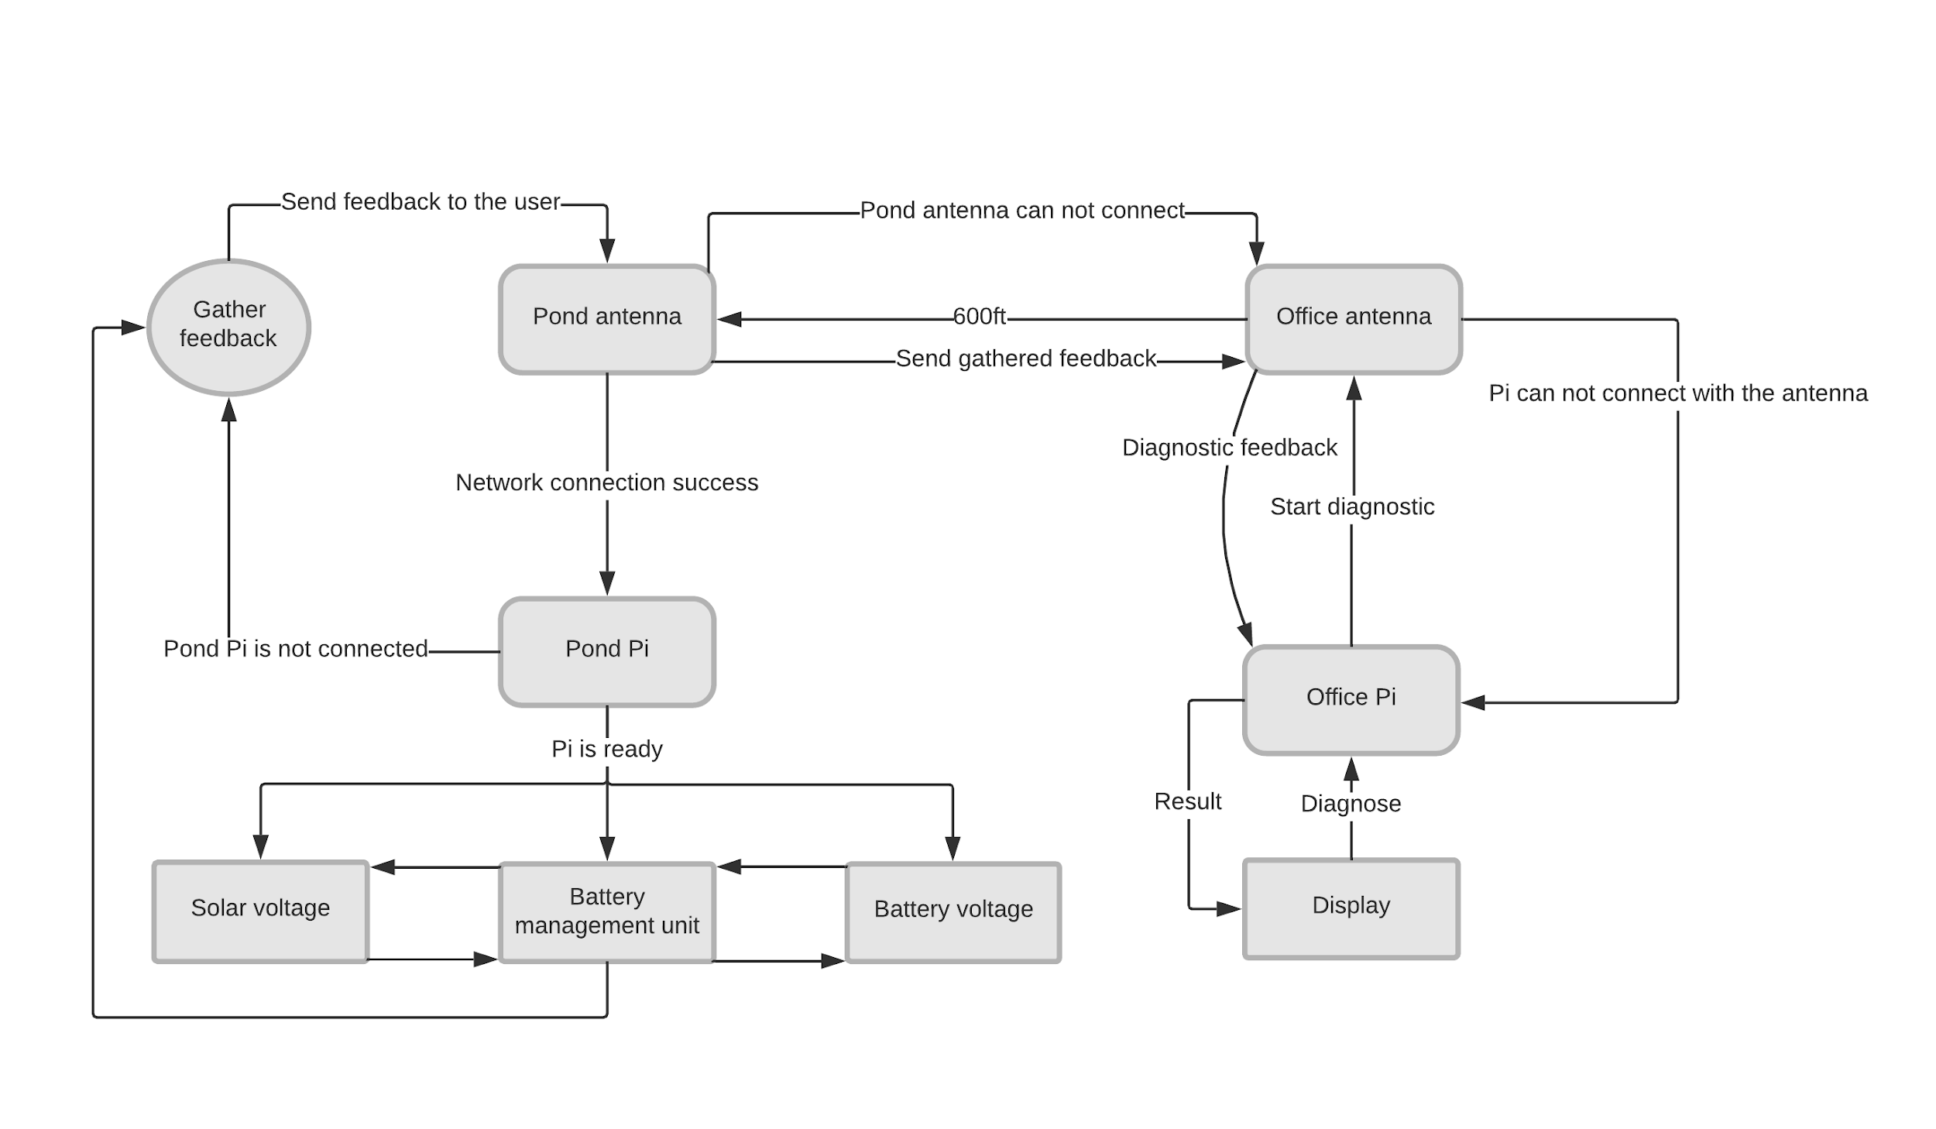

*Figure 1: Self-diagnostic remote monitoring system.*

# Project Scope Description

|  |  |  |  |  |
| --- | --- | --- | --- | --- |
| **Project Schedule** | | | | |
| **Task** | **DRI** | **Duration, Weeks** | **Start** | **End** |
| SOW – Executive Summary | Andres | 2 | 02/06/19 | 02/18/19 |
| SOW – Business Need | Nicholas | 2 | 02/06/19 | 02/18/19 |
| SOW – Product Scope | Andres | 2 | 02/06/19 | 02/18/19 |
| SOW – Project Scope | Ahmed | 2 | 02/06/19 | 02/18/19 |
| SOW – Sponsor Support | Nicholas | 2 | 02/06/19 | 02/18/19 |
| SOW – Approvals | Ahmed | 2 | 02/06/19 | 02/18/19 |
| Install Evaluation | Ahmed | 0.1 | 02/19/19 | 02/19/19 |
| Install Limitations | Ahmed | 0.1 | 02/19/19 | 02/19/19 |
| Research – Battery Level Sensor | Ahmed | 1.75 | 02/19/19 | 03/03/19 |
| Research – Stream Data | Ahmed | 1.75 | 02/19/19 | 03/03/19 |
| Research – System Self Check | Nicholas | 1.75 | 02/19/19 | 03/03/19 |
| Research – Communication | Nicholas | 1.75 | 02/19/19 | 03/03/19 |
| Research – Verify Data Boundary | Nicholas | 1.75 | 02/19/19 | 03/03/19 |
| Research – Display Data | Andres | 1.75 | 02/19/19 | 03/03/19 |
| Research – Data Analysis | Andres | 1.75 | 02/19/19 | 03/03/19 |
| Functional Spec - Intro | Nicholas | 1 | 03/04/19 | 03/11/19 |
| Functional Spec - Functional Description | Ahmed | 1 | 03/04/19 | 03/11/19 |
| Functional Spec - Proj. Alignment Matrix | Andres | 1 | 03/04/19 | 03/11/19 |
| Functional Spec - References | Ahmed | 1 | 03/04/19 | 03/11/19 |
| Create Order Request | Andres | 0.25 | 03/11/19 | 03/13/19 |
| Initial Design Reviews | Ahmed | 2.5 | 03/12/19 | 04/01/19 |
| labor, Cost & Schedule Document | Nicholas | 1 | 04/01/19 | 04/08/19 |
| Draft Poster | Ahmed | 3 | 04/01/19 | 04/22/19 |
| Test Plan | Nicholas | 4 | 04/01/19 | 05/01/19 |
| Individual Report | All | 1.5 | 04/24/19 | 05/02/19 |
| Senior Design Day | All | 0.75 | 03/03/19 | 05/07/19 |

# Sponsor Support Elements

Nicholas Holleman:

|  |  |  |
| --- | --- | --- |
| **Sponsor Support Elements** | | |
| **Element** | **First Needed** | **Needed Until** |
| Any site safety requirements for site | 2/18/2019 | 5/6/2019 |
| Access to the retention pond | 2/18/2019 | 5/6/2019 |
| Access to the office by appointment | 2/18/2019 | 5/6/2019 |
| Statement of work feedback | 2/13/2019 | 2/15/2019 |
| Statement of work signature | 2/14/2019 | 2/17/2019 |
| Functional specification feedback | 3/5/2019 | 3/8/2019 |
| Functional specification signature | 3/7/2019 | 3/10/2019 |
| Sponsor to participate in initial design review | 4/1/2019 | 4/3/2019 |
| Updated functional specification feedback | 3/31/2019 | 4/3/2019 |
| Updated functional specification signature | 4/3/2019 | 4/9/2019 |
| Poster review signature | 4/20/2019 | 4/23/2019 |
| Guidance on labor cost scheduled | 4/8/2019 | 4/22/2019 |
| Final publication of poster | 4/23/2019 | 5/6/2019 |

# Approvals

The signatures of the people below indicate an understanding in the purpose and content of this document by those signing it. By signing this document, you indicate that you approve of the proposed project outlined in this Statement of Work and that the next steps may be taken to create a Functional Specification and proceed with the project.

|  |  |  |  |
| --- | --- | --- | --- |
| **Approver Name** | **Title** | **Signature** | **Date** |
| Ahmed Al Qaysi | Project Manager |  |  |
| Aaron Wiseman | D2 Project Manager |  |  |
| Dr. Stan McClellan | Faculty Advisor |  |  |
| Charlie-Will Tuttle | Sponsor |  |  |
| Dr. Stan McClellan | Instructor |  |  |